**...Press Release...Press Release...Press Release...**

**Embargoed – 00.01am Thursday June 11th 2015**

**Scotland launches SelfHelp4Stroke: Free E Learning Resource**

Stroke survivors, carers and health professionals across Scotland have welcomedSelfHelp4Stroke, the first comprehensive, web-based, free training programme for anyone in Scotland who has had a stroke in Scotland. Led by Scotland’s Health Charity, Chest Heart & Stroke Scotland (CHSS), the resource launches in Stirling on June 11th.

SelfHelp4Stroke Project Manager Heather Bryceland explained, “SelfHelp4Stroke can help you gain control of your life after your stroke by helping you set goals and supporting you to achieve them. The site is full of interactive content, animations, film and audio clips that explain things in detail plus links to resources and information that can be downloaded directly. It has been designed to provide practical tips and advice to help people understand and manage their own condition better and to improve their health, wellbeing and quality of life.”

The content of SelfHelp4Stroke was written by stroke healthcare professionals from across Scotland and by people that have had a stroke.

Stroke survivor from Lanarkshire John Fogarty, 60, is a former Commercial Manager with British Airways who suffered a stroke whilst recovering from an operation for pancreatic cancer. John said: “As someone who has had a stroke, I’m delighted to be involved in SelfHelp4Stroke, and I’m totally sold on the self-management strategy. There is a wealth of valuable information in this website, and I’m sure it will change the lives of many people post-stroke.”

Stroke health professional and NHS Fife Head Occupational Therapist Charlie Chung said, “The SelfHelp4Stroke website is designed to directly help stroke survivors who are able to use a tablet or smart phone, to manage their condition physically and psychologically by accessing ideas from how others have managed their condition. The resulting resource includes person scenarios and video clips together with information on keeping well, being active, emotional support, coping with setbacks and other practical self management tips.

The project was delivered by CHSS in partnership with NHS Education for Scotland and the University of Edinburgh with funding from the Scottish Government. You can access this dynamic stroke education tool after June 11th by visiting [www.selfhelp4stroke.org](http://www.selfhelp4stroke.org)

**ENDS**

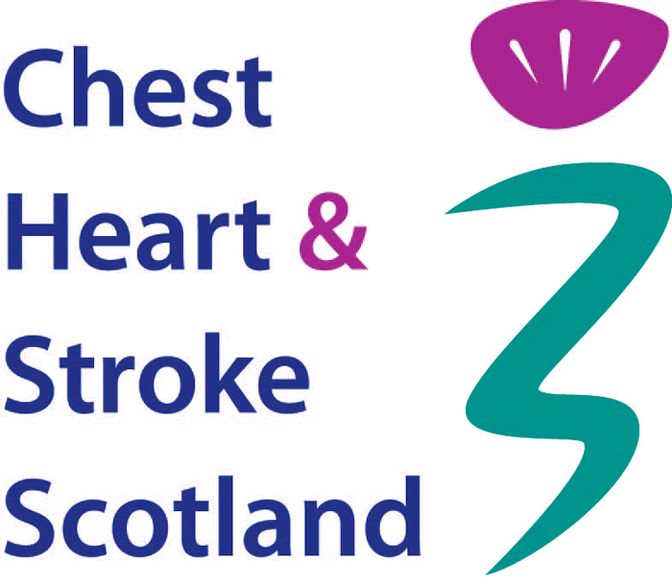

**Editor’s note:**



The SelfHelp4Stroke promotional video can be accessed via [www.selfhelp4stroke.org](http://www.selfhelp4stroke.org)

**Launch information:  
Thursday 11th June: The SelfHelp4Stroke website will be demonstrated from 12.00 to 1.00pm at the Scottish Stroke Allied Health Professional Conference at Stirling Management Centre.**

Media enquiries: Jan Buncle, Director of Public Relations

Tel: 0131 225 6963 email: [jan.buncle@chss.org.uk](mailto:jan.buncle@chss.org.uk)

Date: June 10th 2015

Chest Heart & Stroke Scotland,

3rd Floor Rosebery House

9 Haymarket Terrace

Edinburgh EH12 5EZ

